Saina Nehwal falls short in All England Open Championship: PM Narendra Modi hails Saina Nehwal’s efforts
| March 09, 2015

PM Narendra Modi hails Saina Nehwal’s efforts in All England Badminton Chamionships - "Well played @NSaina! We are very proud of you. You created history by reaching the finals. Keep up the spirit," Modi wrote on his Twitter page.
Ads by Google
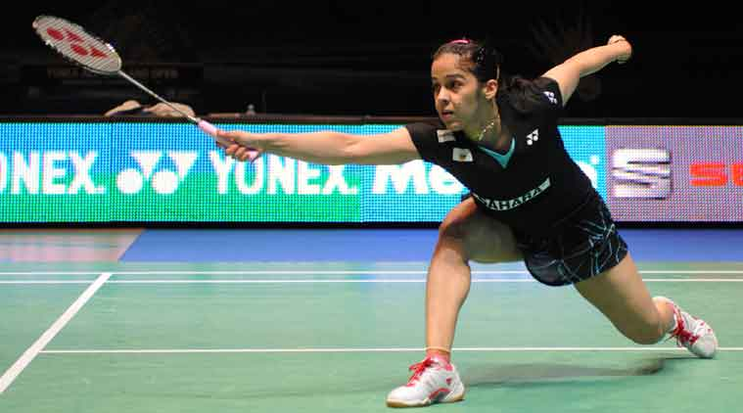
New Delhi: Prime Minister Narendra Modi on Sunday praised Saina Nehwal after the ace Indian female shuttler suffered a heartbreaking defeat against Carolina Marin in the final of the All England Badminton Championships, saying the Country is proud of her for creating history by reaching the summit clash.
World Champion Carolina Marin of Spain staged a remarkable comeback to win the All-England Championships on Sunday. Saina Nehwal was bidding to become the first All-England Women’s Singles winner from India as the odds were stacked in her favour to achieve a fourth victory over the Spaniard -- the Indian having already beaten Marin to the Syed Modi International Title in January 2015.
"The game just went away from me," admitted Nehwal. "I was playing very cool but I began to hurry my shots and I made errors. I tried to play it safe. Playing against top players anything can happen at any stage, and you can always get nervous at some point in time. That's what happened here," she added.
Marin became the first left hander to win the Championship in Birmingham. This was only second time in a decade when two non-Chinese players played in the Women's Singles final at the All England Championships. In 2013 Tine Baun of Denmark beat Thai Ratchanok Inthanon in the final. .Xie Xingfang (2005, 2006, 2007), Wang Yihan (2009), Wang Shixian (2011, 2014), Li Xuerui (2012) have made All England a happy hunting ground for burgeoning Chinese Badminton players.
Saina's best result in this BWF Superseries Premier event had been two Semi-final appearances in 2010 and 2013. In her previous eight appearances, starting 2007, she also made three other Quarter-finals.
On International Women's Day, the third-seeded Indian looked in great touch and started with supreme confidence, which comes from not dropping a set the whole week. Having beaten two top Chinese players -- Wang Yihan and Sun Yu -- en route to the final, Saina was the overwhelming favourite against the sixth-seeded Carolina. Saina built a comfortable 11-6 lead in the first game and never looked back. She won her first game in 19 minutes as Carolina made several unforced errors at the net.
Nehwal At 20-11 in first set, Indians were readying to light up the firecrackers and celebrate their biggest contemporary woman athlete who would match legends Prakash Padukone and Pullela Gopichand as All England Champions. Nehwal was operating at a high pace and smashing it around, when Marin got going on her overhead shots, where she strikes the shuttle very early and high in the air and magnifies her reach when swatting winning placements. From 20-11 – 9 set points for the Indian — Marin would offer a peek into her combative resistance, not giving up and punching holes into the third seeded Indian’s flurry of one-sided agro as she’s narrow the gap to 20-16.
Nehwal won the first set, and even led 11-9 at break in the second, but Marin had now hit her stride. Responding to fast with faster, Marin used her freakish hand speed and quick reactions to get into position and dictate placement of her shuttles.

Pretty soon after the break, She was being snared into errors and even as Marin leveled at 13-13 and sneaked ahead at 14-13, As a last ditch Nehwal attempted to lower the pace of the rallies, slow down the game after she’d lost the second set 21-14.
The World No. 3 Indian let go of a huge opportunity to script history as she squandered an opening game lead to go down 21-16 14-21 7-21 to the reigning World Champion in the Women’s Singles final that lasted for little over an hour.
Olympic Bronze Medallist, Saina, thus, falls short to emulate her long-time Coach Pullella Gopichand (2001) and legendary Prakash Padukone (1980), who had won the prestigious Title in the past.
------------------------------------

